**Hexaware Coding Challenge(04/10/2024) Divya Sree Murali**

**Virtual Art Gallery**

**Creating DataBase**

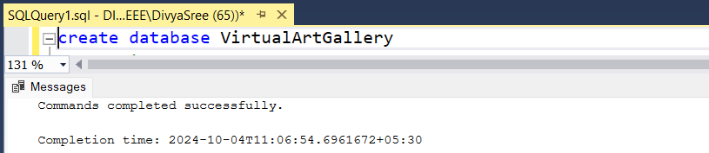

**Creating tables for artists and categories**

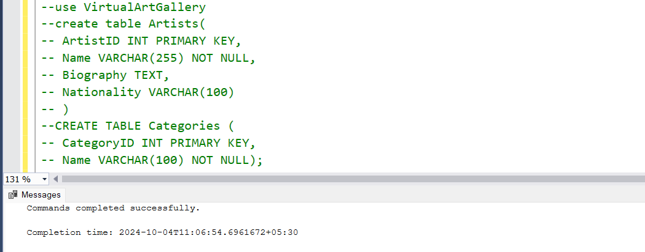

**Creating Artworks table and specifying the relations with other tables using foreign keys**

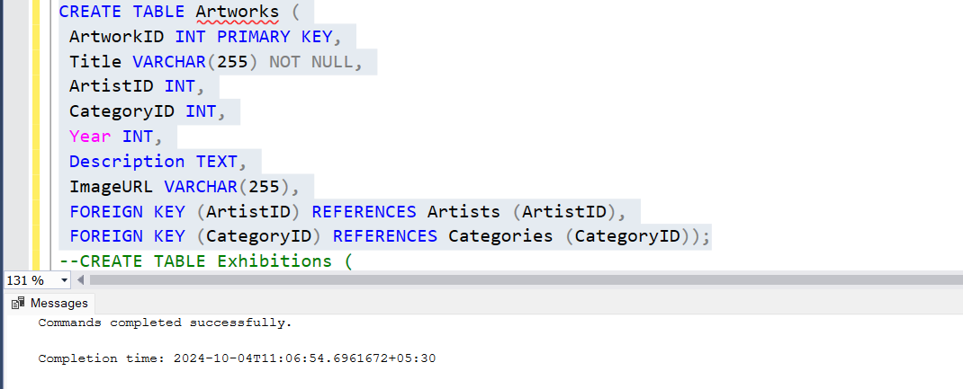

**Creating tables exhibitions and exhibitionstable as specified**

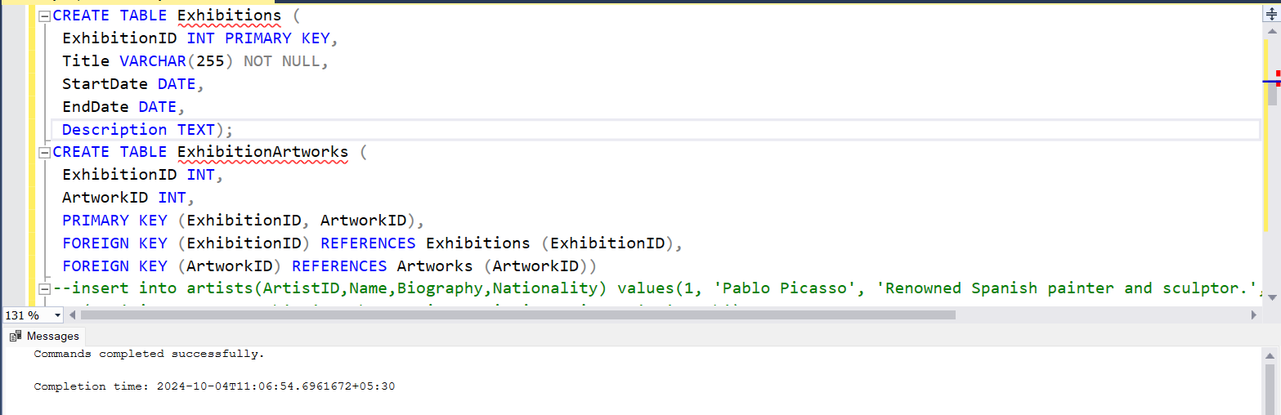

**Inserting sample records into the table**

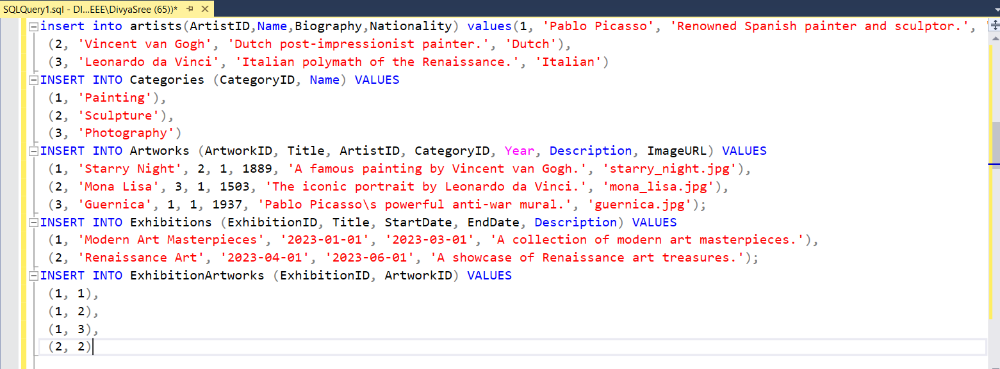

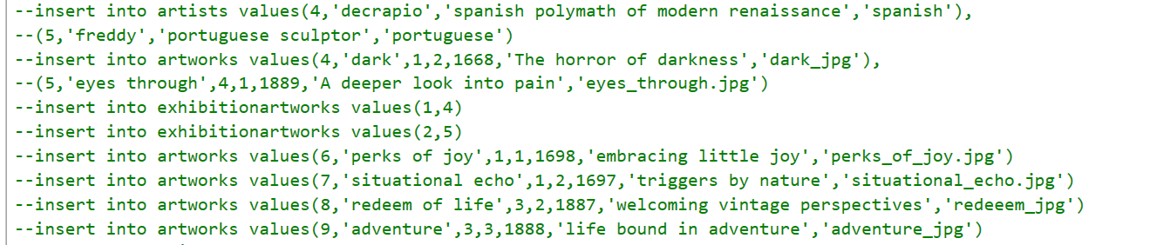

1. **Retrieve the names of all artists along with the number of artworks they have in the gallery, and list them in descending order of the number of artworks.**

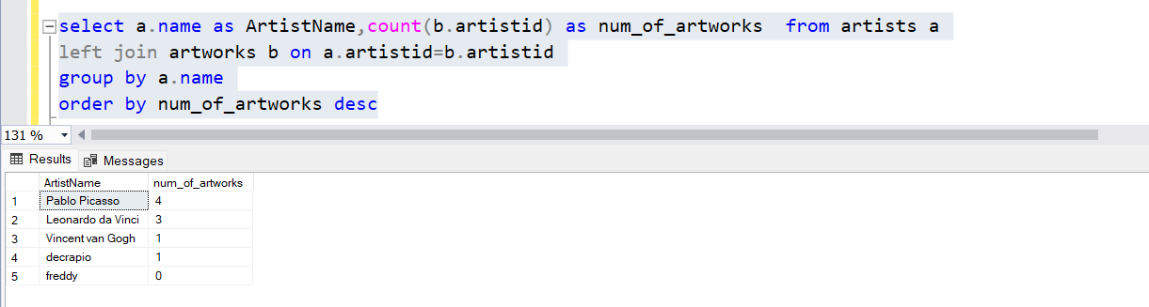

1. **List the titles of artworks created by artists from 'Spanish' and 'Dutch' nationalities, and order them by the year in ascending order**

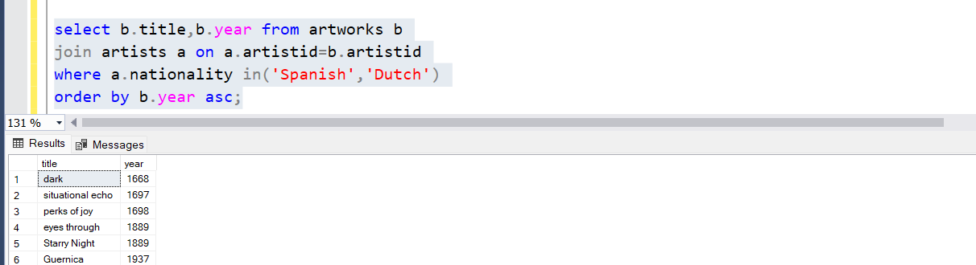

**For reference, I have added years in order to specify they are arranged in ascending order**

1. **Find the names of all artists who have artworks in the 'Painting' category, and the number**

**of artworks they have in this category.**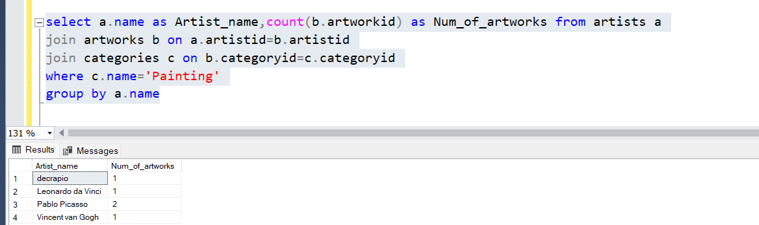

1. **List the names of artworks from the 'Modern Art Masterpieces' exhibition, along with their artists and categories.**

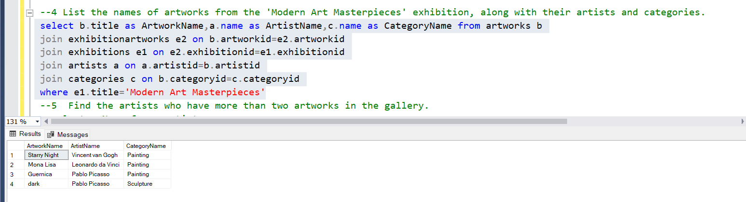

1. **Find the artists who have more than two artworks in the gallery.**

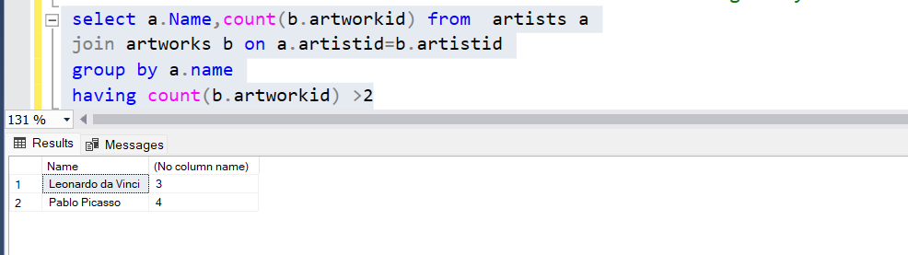

**For reference, I have added the count of artworks**

**6. Find the titles of artworks that were exhibited in both 'Modern Art Masterpieces' and**

**'Renaissance Art' exhibitions**

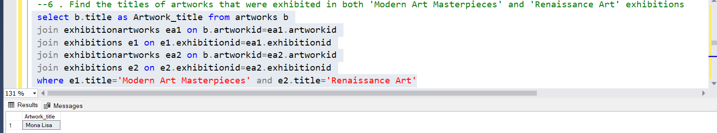

**7.Find the total number of artworks in each category**

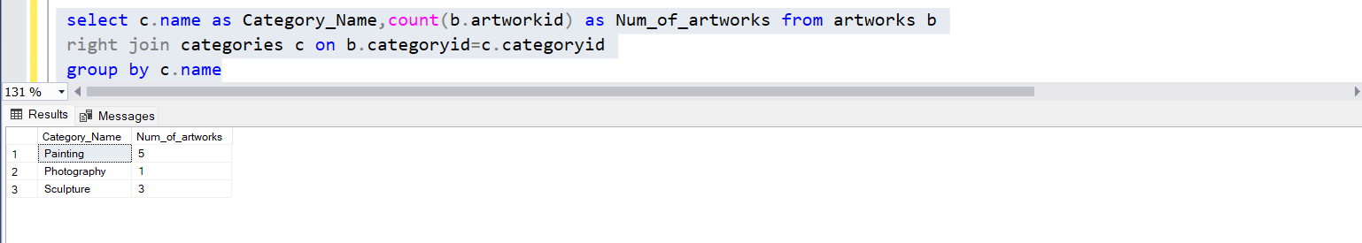

**8.List artists who have more than 3 artworks in the gallery.**

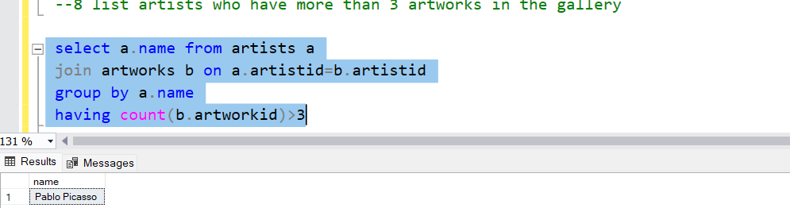

**9. Find the artworks created by artists from a specific nationality (e.g., Spanish).**

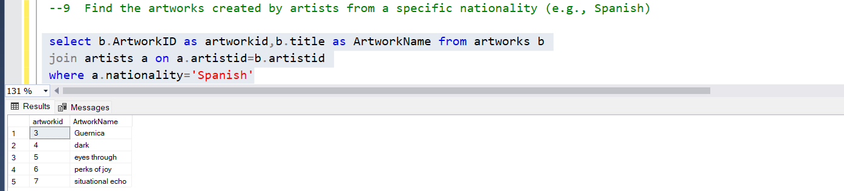

**10. List exhibitions that feature artwork by both Vincent van Gogh and Leonardo da Vinci.**

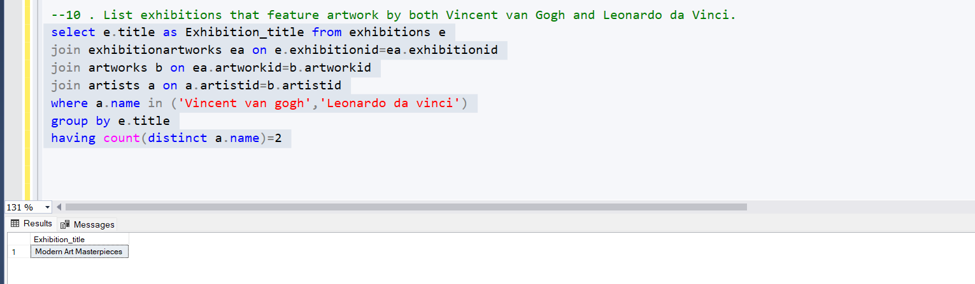

**11. Find all the artworks that have not been included in any exhibition.**

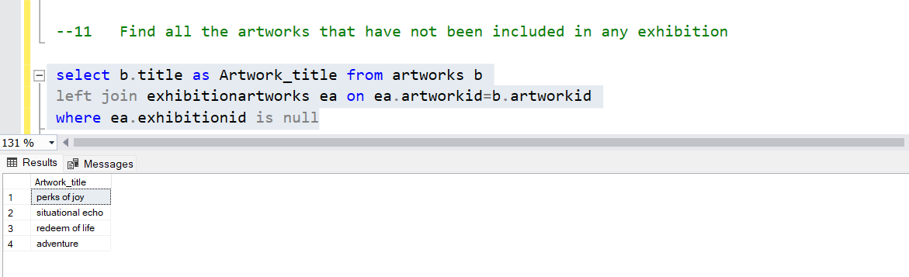

**12. List artists who have created artworks in all available categories.**

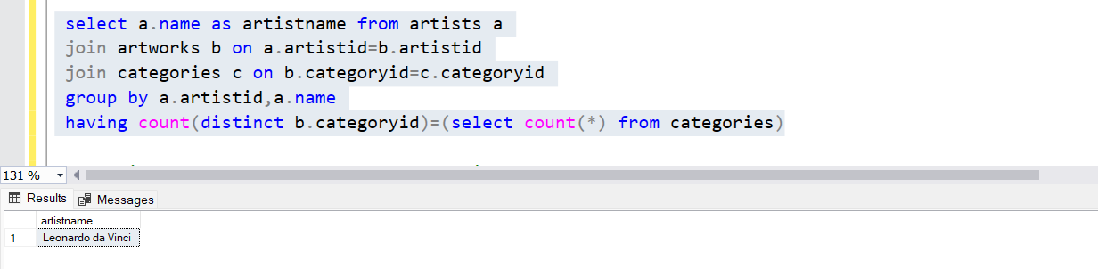

**13. List the total number of artworks in each category.**

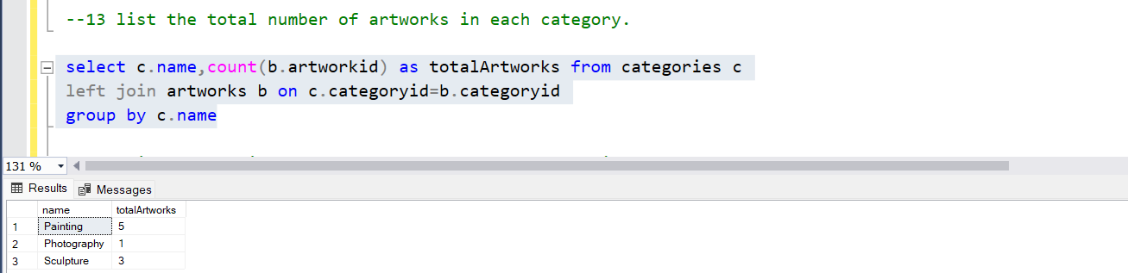

**14. Find the artists who have more than 2 artworks in the gallery.**

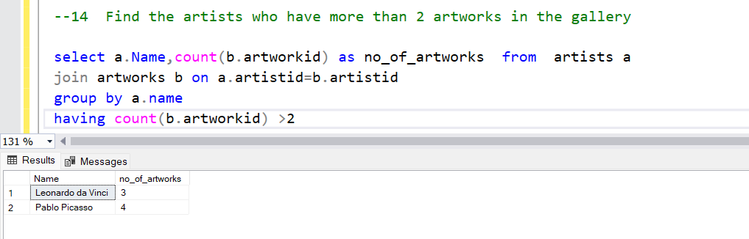

**15. List the categories with the average year of artworks they contain, only for categories with morethan 1 artwork.**

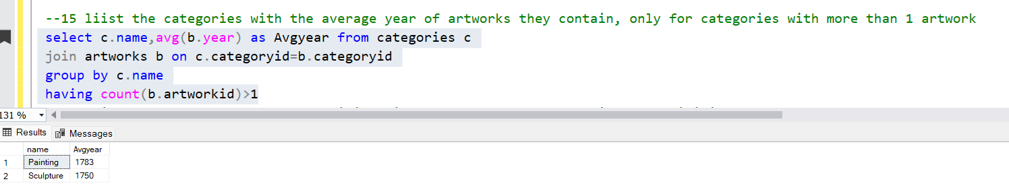

**16. Find the artworks that were exhibited in the 'Modern Art Masterpieces' exhibition.**

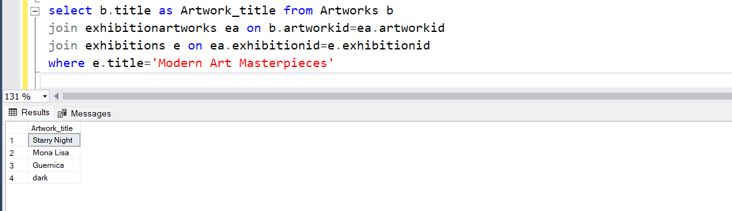

**17. Find the categories where the average year of artworks is greater than the average year of all artworks.**

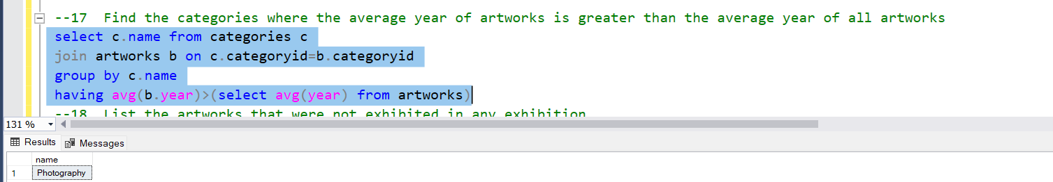

**18. List the artworks that were not exhibited in any exhibition.**

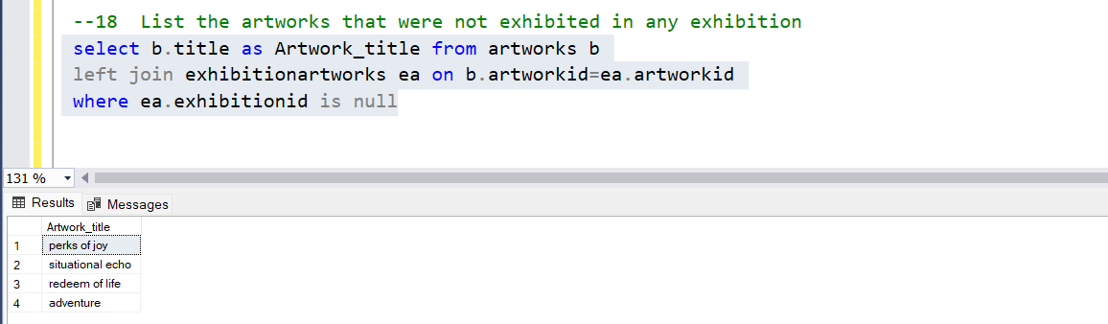

**19. Show artists who have artworks in the same category as "Mona Lisa.**

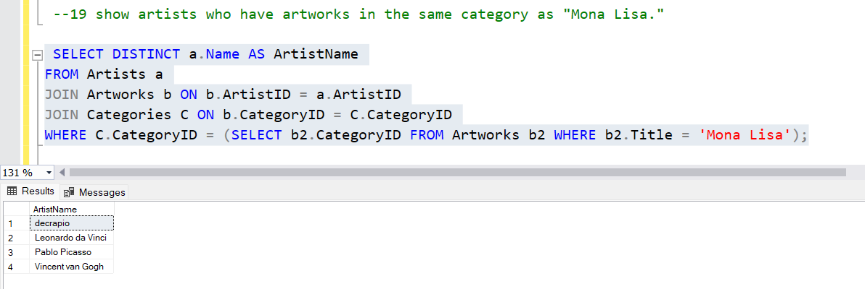

**20.** **List the names of artists and the number of artworks they have in the gallery.**

